Summer Reading Fun!

There’s nothing quite like a hot day, a lawn chair, and a great story!
In order to give all middle school students a jumpstart on the upcoming school year, some independent reading over the summer is in order. I have selected three book options for each grade. Below are the grade level themes, the novel selections, and a little snippet about each plot. Our first few days of ELA will focus on group projects and discussions for these novels, so success depends on everyone reading one of the choices. Hint: Don’t wait until the last minute! The books are to be savored, not read under pressure!

6th Grade Reading Choices center on the theme of self-discovery and confidence.
Hatchet, by Gary Paulsen, is a story of adventure. Thirteen-year-old Brian is a lone survivor of a plane crash in the Canadian wilderness. This fiction story will keep you on the edge of your seat as Brian must depend on his wits, develop his courage, and persevere through several trials to discover a new perception of priorities and himself.
Bridge to Terabithia, by Katherine Paterson, is a story of character growth. This surprising relationship between a cautious farm boy named Jesse and a brave artistic girl named Leslie leads both of them to develop confidence and a friendship neither has experienced prior. Their fictional world of Terabithia allows a world of imagination that surprisingly allows them be more true to themselves.
Among the Hidden, by Margaret Peterson Haddix is a story of freedom. In an alternate world with a government that controls all, even the number of children families may have, Luke is forced to remain hidden inside his home to avoid discovery. It isn’t until he braves leaving the house to befriend a new neighbor, Jen, also a shadow child, that he learns to live. Unfortunately, life isn’t always kind to the brave.

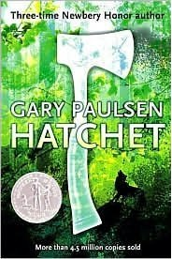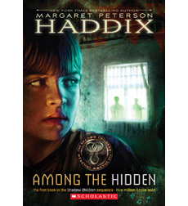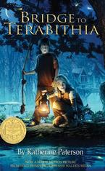
Summer Reading Fun!

There’s nothing quite like a hot day, a lawn chair, and a great story!
In order to give all middle school students a jumpstart on the upcoming school year, some independent reading over the summer is in order. I have selected three book options for each grade. Below are the grade level themes, the novel selections, and a little snippet about each plot. Our first few days of ELA will focus on group projects and discussions for these novels, so success depends on everyone reading one of the choices. Hint: Don’t wait until the last minute! The books are to be savored, not read under pressure!

7th Grade Reading Choices center on the theme of fresh starts.
The Whipping Boy, by Sid Fleishmann is a short novel about two young boys who live in Medieval Europe. One is a prince who is purposely troublesome. The other is the “whipping boy” who receives the prince’s beatings for him. A comic turn of events outside the palace causes the young men to rely on each other and to see the world from each other’s perspective. This is a reaffirming story of the power of people to change and do well in adversity.

The Truth about Sparrows, by Marian Hale is another tale of fresh starts after tragedy. Sadie's family is forced to leave their Missouri home and look for work in Texas. The Great Depression doesn’t provide many opportunities, however, and Sadie must come to terms with a shack in Texas, tough work, and new friends. Sadie learns, however, that helping others is the best self-help.

Percy Jackson and the Lightening Thief, by Rick Riordan is an exciting adventure mixing Greek mythology and contemporary American worlds. Percy’s troubled mortal life blows up when he is outed as a demigod. Oh, and blamed for stealing Zeus’s lightning bolt. And forced to fight the gods of Olympus in a race to save his mother from Hades. But other than those small challenges, his new identity is just great. Okay, his new life stinks, but in it, he finds a community like himself, and who he is really meant to be.

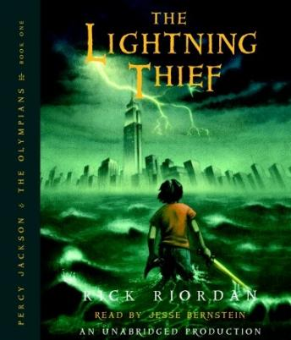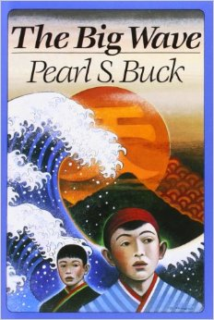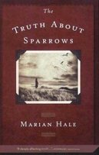
Summer Reading Fun!

There’s nothing quite like a hot day, a lawn chair, and a great story!
In order to give all middle school students a jumpstart on the upcoming school year, some independent reading over the summer is in order. I have selected three book options for each grade. Below are the grade level themes, the novel selections, and a little snippet about each plot. Our first few days of ELA will focus on group projects and discussions for these novels, so success depends on everyone reading one of the choices. Hint: Don’t wait until the last minute! The books are to be savored, not read under pressure!
8th Grade Reading Selections center on the theme of strength in community. Self-reliance is all well and good, but we are interconnected, and better combining our talents.
Freak the Mighty by Rodman Philbrick is a shorter novel that packs a tall message. Max, the main character is mighty of body, but slower of mind. His new neighbor is small of body but mighty-minded. The two make…Freak the Mighty. Their developing friendship and shared talents allow both to lead a better life, until the past catches up with Max, and reality crashes on both in a surprising, emotional conclusion.

Legend, by Marie Lu, is a dystopian novel set in a new America of warring governments. Our heroine June has been tasked with bringing down the enemy of the Republic, Day, blamed for murdering her brother. She can, and does, but realizes all is not what it seems in this state where class lines are severely drawn, and those who do not stay in their lines are severely punished. Can the two move past their past and connect to correct injustice?

Homecoming, by Cynthia Voight, is a long-standing favorite young adult novel. The main characters struggle to survive as they are abandoned by their parents. The siblings must make their own way, with a lot of walking and disappointments as they trying to find a “community.” They find home, finally, but also find self-reliance along the way.
